**Setting up Jenkins pipeline**

In this demo we are going to build a Docker Jenkins pipeline to implement CI/CD workflow.

This demo can be done in mainly two steps:

1. Installing Docker plugin and configuring Docker cloud
2. Configuring Freestyle Jenkins job

**Installing Docker plugin and configuring Docker cloud**

We have to Docker cloud by accessing Manage Jenkins 🡪 Configure system. Then you have to add Docker cloud details as per below:

Docker Host URI unix:///var/run/docker.sock

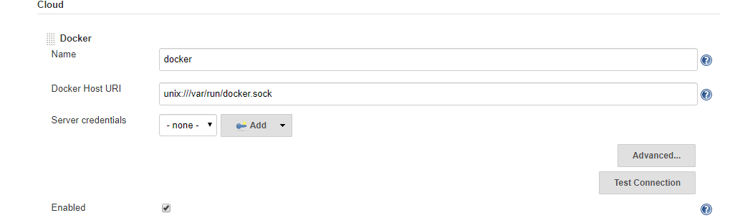

In order to configure the Docker cloud we need to give complete access to docker.sock file so that Jenkins will be able to connect to Docker process.

chmod 777 /var/run/docker.sock



**Configuring Freestyle Jenkins job**

Create new Jenkins pipeline job for supporting CI/CD workflow.

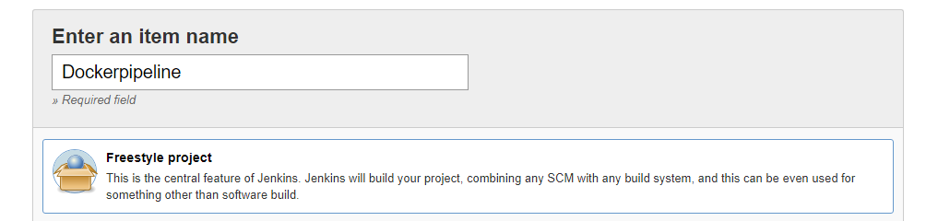

Once job is created we can configure git repository so that we can have Dockerfile to build Docker container and push to Docker hub.

https://github.com/Anuj1990/Docker.git

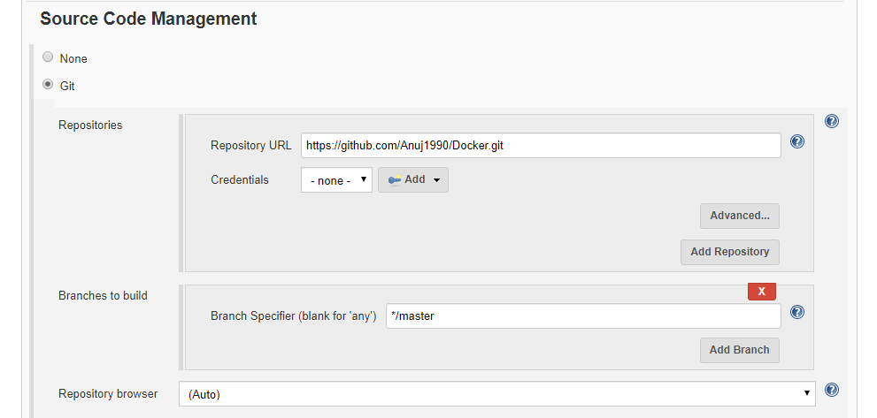

Now we have to configure build triggers to enable Poll SCM feature so that once any push is detected build will automatically trigger build.

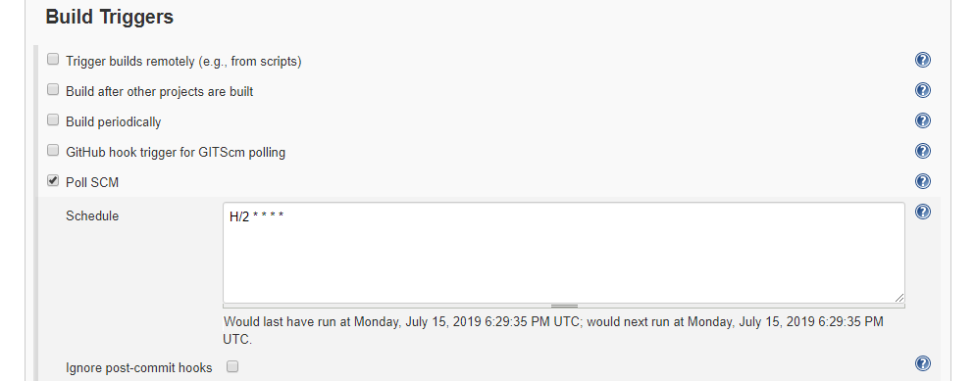

Now we have to configure Docker build option to configure build configurations. Some of the configurations are mentioned below:

Directory for Dockerfile . (Represents current location)

Docker Registry URL https://index.docker.io/v1/

Docker credentials Docker hub username password

Cloud Select Docker Cloud created in dropdown

Image anujsharma1990/phpcode:${BUILD_NUMBER}

Registry Credentials Docker hub username password

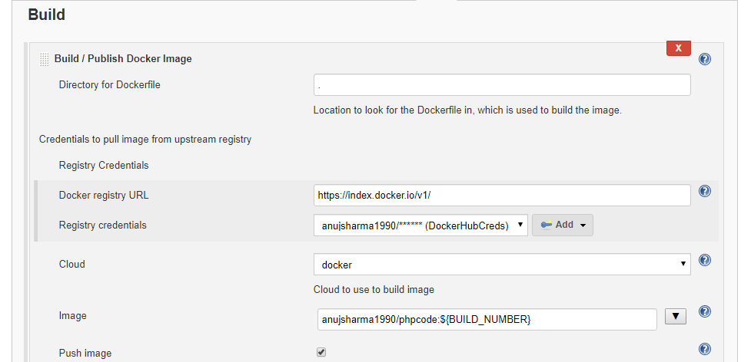

Now with this we have configured how our custom Docker image will be pushed to Docker hub and now we have to configure the Docker container deployment configurations.

Follow below mentioned steps to configure how Docker containers will be deployed.

Docker cloud Select from dropdown Docker cloud details

Docker image anujsharma1990/phpcode:${BUILD_NUMBER}

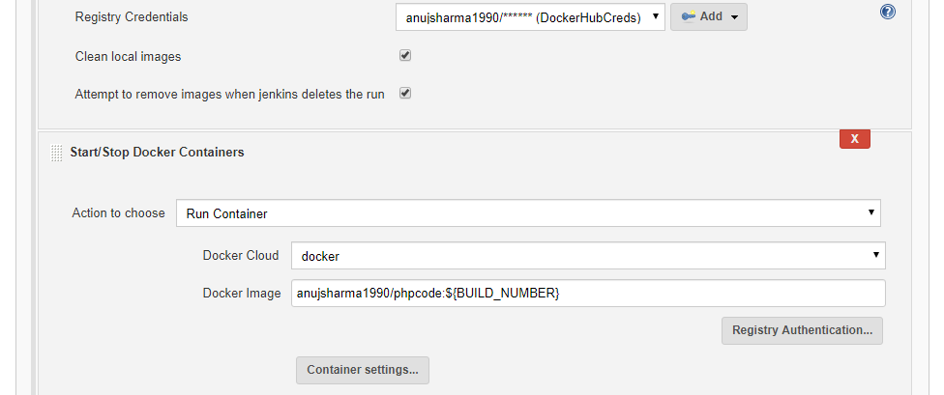

Once job configuration is done save the configuration and proceed with triggering build so that we can build custom container and deploy container.

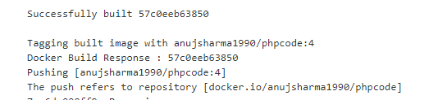

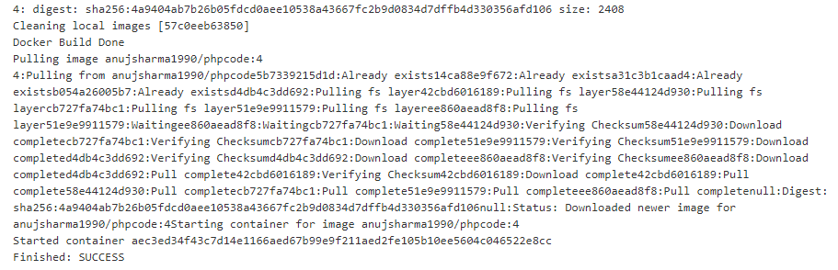

Once build is successful we can validate the Docker container deployment on Docker host which will help us to implement complete CI/CD workflow for Docker container.

